**Name:** Abhay Mathur **Sapid:** 60017210016 **Batch:** A1

**Experiment No. 3**

**Aim:** Image Denoising

**Objective:** Develop a program to add noise & remove it by different operators

**Theory:**

Smoothing

Low pass filtering removes the high frequency content from the image. It is used to remove the noise present in the image which is generally a high frequency signal.

1. Averaging Filter

If an image has Gaussian noise, a low pass averaging filter is used to remove the noise. The frequency response and spatial response is show below.

1

1

1

1

1

1

1

1

1

1/9

Frequency

Spatial Domain

Averaging Mask

From spatial response we generate the mask that would give us the low pass filtering operation. Here all the coefficients are positive and the multiplying factor for a M X N matrix is 1 / (M X N).

1. Median Filtering

The averaging filter removes the noise by filtering it till it is no longer seen. But in the process it also blurs the edges. If e use averaging filter to remove salt and pepper noise from an image it will blur the noise but will also ruin the edges. Hence when we need to remove salt and pepper noise we use non-linear filter known as Median Filter. They are also called order statistical filters because their response is based on the ordering and ranking of the pixels contained within the mask.

**Image Denoising in OpenCV**

OpenCV provides four variations of this technique.

[cv.fastNlMeansDenoising()](https://docs.opencv.org/3.4/d1/d79/group__photo__denoise.html#ga4c6b0031f56ea3f98f768881279ffe93) - works with a single grayscale images

[cv.fastNlMeansDenoisingColored()](https://docs.opencv.org/3.4/d1/d79/group__photo__denoise.html#ga03aa4189fc3e31dafd638d90de335617) - works with a color image.

[cv.fastNlMeansDenoisingMulti()](https://docs.opencv.org/3.4/d1/d79/group__photo__denoise.html#gaf4421bf068c4d632ea7f0aa38e0bf172) - works with image sequence captured in short period of time (grayscale images)

[cv.fastNlMeansDenoisingColoredMulti()](https://docs.opencv.org/3.4/d1/d79/group__photo__denoise.html#gaa501e71f52fb2dc17ff8ca5e7d2d3619) - same as above, but for color images.

**Common arguments are:**

h : parameter deciding filter strength. Higher h value removes noise better, but removes details of image also. (10 is ok)

hForColorComponents : same as h, but for color images only. (normally same as h)

templateWindowSize : should be odd. (recommended 7)

searchWindowSize : should be odd. (recommended 21)

**Problem Definition**

* Add Noise & Remove it using different Operators
* Use OpenCV to denoise Images

**Observations**

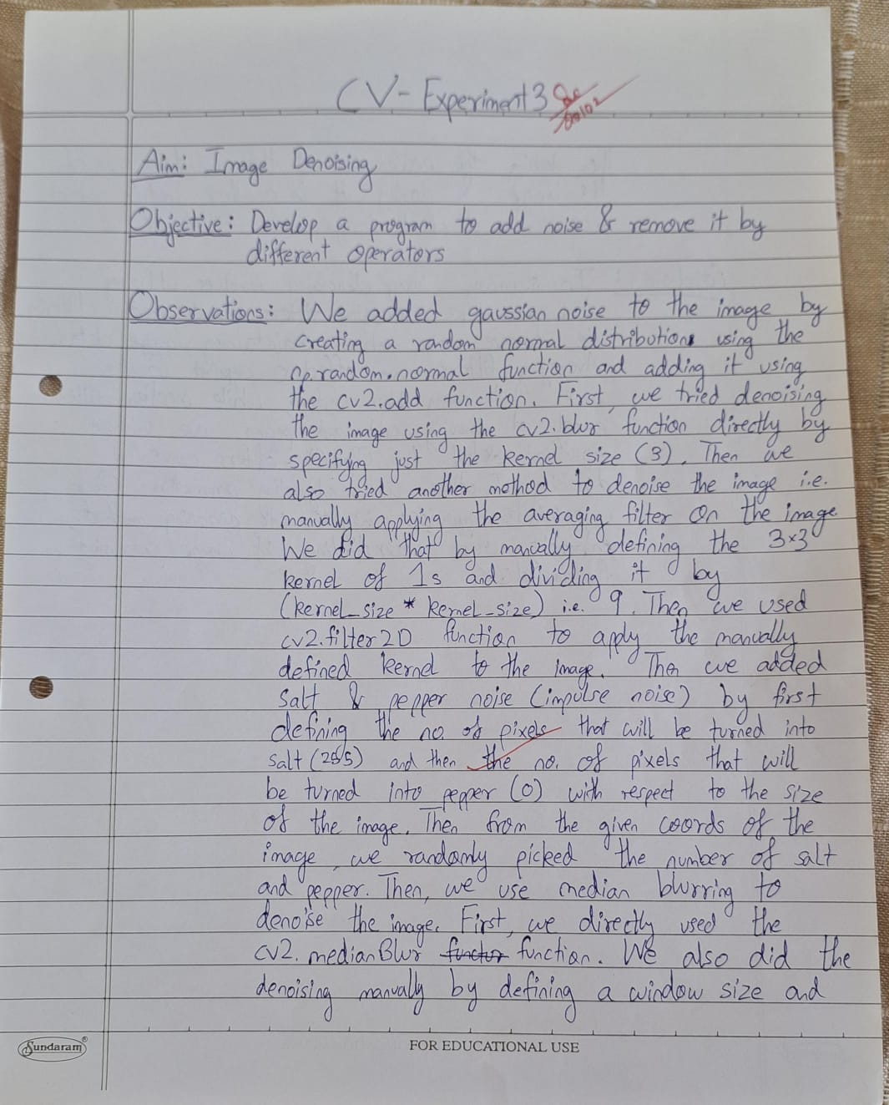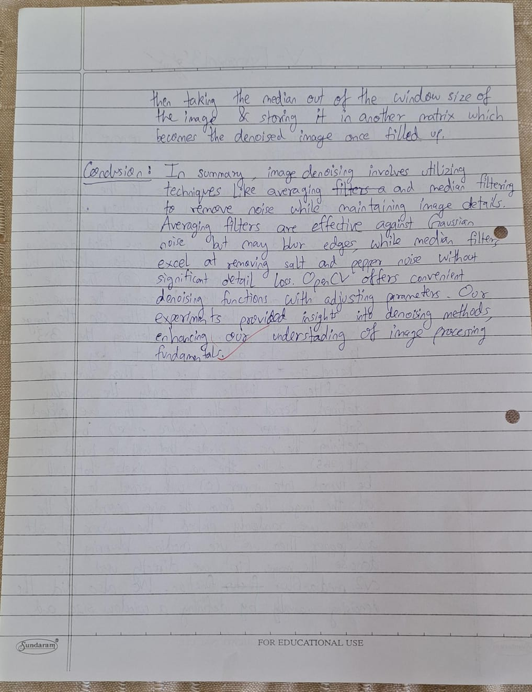

**Conclusion**

In summary, image denoising involves utilizing techniques like averaging and median filtering to remove noise while maintaining image details. Averaging filters are effective against Gaussian noise but may blur edges, while median filters excel at removing salt and pepper noise without significant detail loss. OpenCV offers convenient denoising functions with adjustable parameters. Our experiments provided insights into denoising methods, enhancing our understanding of image processing fundamentals.